Project Ideation

Our project aims to create an artificial intelligence, which, by using neural networks, would process black and white images and produce fully and accurately colored images. (Add some stuff here)

A similar project has been attempted by many members in the AI community such as Marcelo Rovai, Richard Zhang, Phillip Isola, etc.

While it is very common to use technology like Keras and OpenCV to implement the convolutional neural network needed for this sort of project, we decided to use PyTorch and GANs. The former allows us to show the underlying work that happens “behind the scenes”, while the latter produces a very accurate model in a very novel way.

There are a number of reasons why we decided this would be a good project to conduct. Firstly, there are a lot of old media examples from wartime photographs to footage in great movies that are, perhaps, threatened to be buried in history due to their ‘dated look’. Bringing them back to life with realistic colors could be a way to preserve them for longer, and also captivate a newer and more modern audience. It would also give a new insight into old media, hopefully by accurately presenting even more what they would have looked like. Secondly, we know that there is a demand for this kind of application, for example on Reddit alone there are multiple communities sharing these kinds of colourised images that attract large audiences. Some subreddits to note in particular are: History In Color (r/ColorizedHistory) with over 500,000 members, and Colorization - The colorization of old black & white photos (r/colorization) with over 100,000 members. We believe this is just a small representation of the fascination many of us have into what these images would have looked like in real life, full in colour. Further, we have identified that there is space for a digital solution that is better than the current solutions. It is an incredibly time consuming process to colourise these images, from the extensive research through the wealth of information that is needed to faithfully reconstruct these colours, to the painstaking process of reconstructing the images to their original state with the layers and layers of added colour; it isn’t uncommon for complex images to need up to a month to colourise by professional artists. Finally, we have also identified that there is space for developments in the machine learning approaches to this problem, due to the inaccuracies found particularly within processing images with warm colors where they mistake them for gray or blue. With all of this in mind, we all see this as an important issue. We are planning to provide a solution which improves on these issues, and perhaps our work on images might lead to the next step which would be converting videos to color too, using a frame by frame approach.

Related projects and materials:

A project called DeOldify by Jason Antic is open sourced, and on Github, and could provide us with the insight and knowledge needed to develop our own method of approaching this task. For his project, he developed a specific way of Generative Adversarial Networks (GAN) training method that is a new and very efficient way to train your model for recolouration purposes. It’s called NoGan and according to Jason Antic (2020) *“****It provides the benefits of GAN training while spending minimal time doing direct GAN training. Instead, most of the training time is spent pretraining the generator and critic separately with more straight-forward, fast and reliable conventional methods.”[1]***

The benefits of using NoGan is that it does not accumulate nearly as many artifacts or glitches of GANs resulting in way more realistic pictures and videos.

Example of GAN and NoGan:

Figure 1. Jason Antic (2020) GAN Figure 2.Jason Antic (2020) NoGan

(Note differences in fluidity and colour stability/deviation)

“Deep Image Prior” is a paper by Dmitry Ulyanov published in 2018 with an open GitHub repository that uses neural networks to denoise and restore images using PyTorch. We will look at this to try and develop a color blending technique to fight the above-mentioned issue of warm colors. According to Dmitry Ulyanov et al. (2018), “***randomly-initialized neural network can be used as a handcrafted prior with excellent results in standard inverse problems such as denoising, super-resolution, and inpainting*.”[2]**

Example: 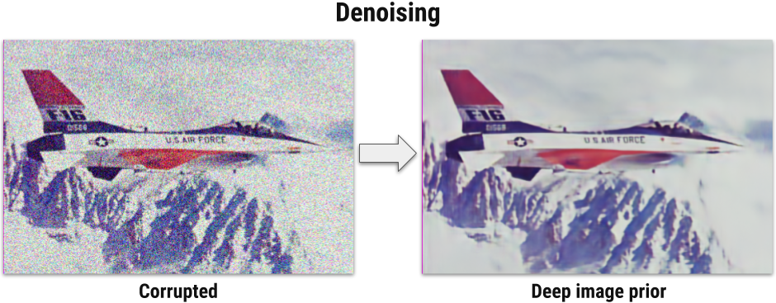

Figure 3. Dmitry Ulyanov et al. (2018) Example of denoising with Deep Image Prior

Fedor Kitashov’s work at Mail.ru to restore photos with the usage of AI offers a unique way of approaching the solution we are seeking to the warm color problem.

For Fedor Kitashov’s project of restoring old war time photos and pictures instead of using regular RGB colorization for the pictures a new algorithm was constructed which instead of using RGB colours, YCbCr colour representation was used. Y component is brightness(luma), Cb is the difference of blue colour and brightness while Cr is the difference of red colour and brightness. The YCbCr representation was used instead of RGB because according to Fedor Kitashov et al ***“A human eye is more sensitive changes in brightness than to color changes.”[3]***

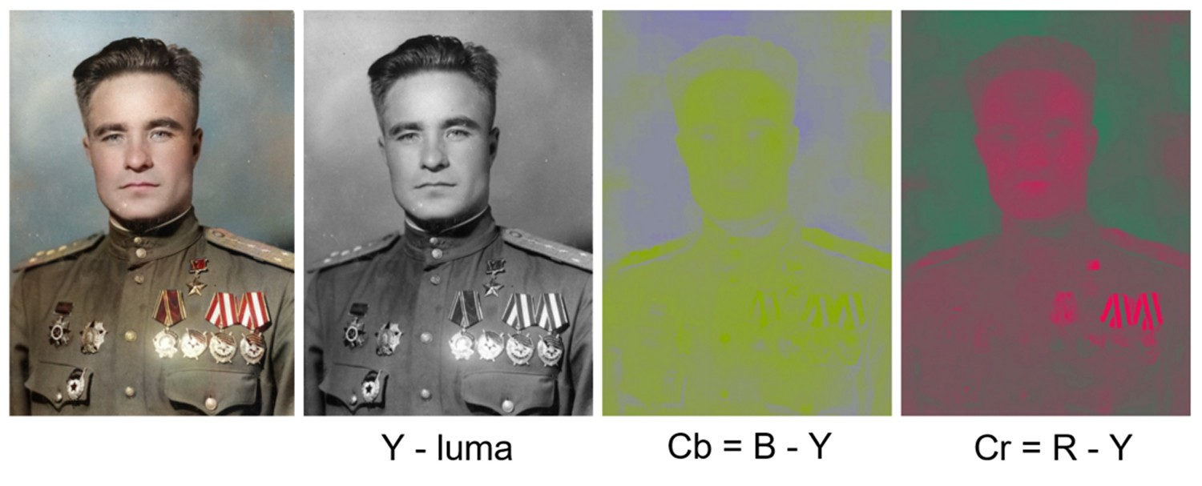

figure 4. Fedor Kitashov et al . (2019) YCbCr demonstration

Colorful Image Colorization is an algorithm trained on over one million pictures made by Richard Zhang, Philip Isola and Alexei A. Efros. This algorithm and paper is going to be the source of most of our research since it is determined to be one of the most successful algorithms that turn grayscale images into plausible color versions of it with a Turing test result of 32% which is incredibly high for a color based algorithm.

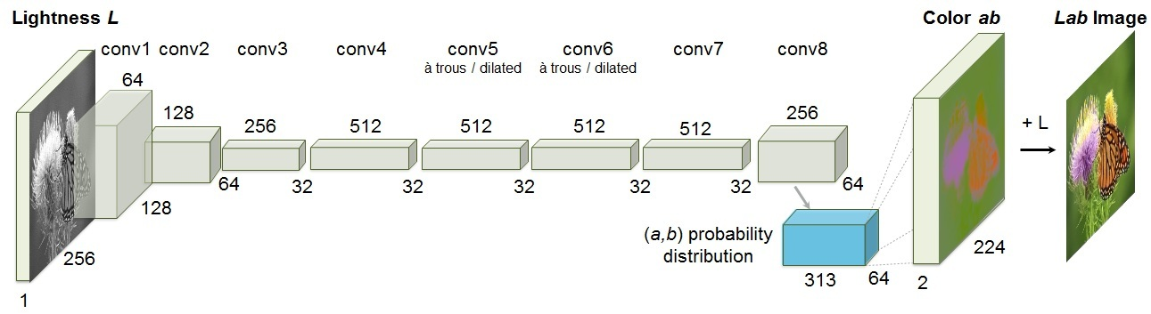

Figure 4. Richard Zhang et al. (2016) demonstration of Colorful Image Colorization algorithm [3]

**Project Statement:**

We plan to create an artificial intelligence which with the use of neural networks will convert black and white pictures into coloured pictures using the methods from combined research. Our plan is to research currently existing approaches, examples and models, and come up with something that could excel in an area that most of the existing models lack. Currently, we see that most of the models have poor performance when working with images that are based on cold color scale. We will try to see what could be the potential cause and we’ll try to come up with a solution that solves those issues, while its model is quick to learn and achieves high accuracy. We plan to produce a model that can be used by people who might not be gifted when it comes to use of technology, but would still like to colorize their old photos and we plan to achieve this by producing a easy to understand Graphical User Interface that enables people to input their own digital pictures into the program.

References:

[1] Antic, J. (2020). *jantic/DeOldify*. [online] GitHub. Available at: https://github.com/jantic/DeOldify [Accessed 10 Mar. 2020].

‌[2] Ulyanov, D., Vedaldi, A. and Lempitsky, V. (2020). Deep Image Prior. *International Journal of Computer Vision*. [online] Available at: https://arxiv.org/pdf/1711.10925.pdf [Accessed 10 Mar. 2020].

‌[3] Kitashov, F. (2020). *AI-Based Photo Restoration*. [online] Medium. Available at: https://medium.com/@fedor.kitashov/ai-based-photo-restoration-6e41469ce0d7 [Accessed 10 Mar. 2020].

[4] Zhang, R., Isola, P. and Efros, A.A. (2016). Colorful Image Colorization. In: *Computer Vision – ECCV 2016*. [online] pp.649–666. Available at: https://arxiv.org/pdf/1603.08511.pdf.